
Department | FED
Subject | DSA-2
Academic Year | I-III Semester(2025-26)
Faculty Name | N.M Deepika
Student Name | CHADA HASIKA
Roll Number | 2520030372
Branch | CSE
Couse Outcome | 1
Case Study Topic: MediFlow Hospital — Appointment-Driven Patient Indexing Using BST and AVL Trees
Work Done Summary:
This case study investigates the patient indexing system used in MediFlow Hospital, where patient records are stored and accessed using unique Patient IDs. The IDs are generated in appointment order and arrive in nearly sorted sequence, creating a challenging scenario for traditional Binary Search Trees (BSTs). The study focuses on analyzing the impact of insertion order on tree structure, search efficiency, and compliance with strict lookup-time Service Level Agreements (SLAs).
The analysis compares the performance of a plain BST and an AVL Tree when processing patient IDs received in appointment order. Tree construction, balancing operations, and deletion handling are examined to understand their effects on lookup performance. The study further evaluates how self-balancing trees maintain efficient search operations despite adversarial insertion patterns.
Implementation Details:
- Analyzed the appointment-based patient ID sequence generated throughout the day.
- Constructed a plain Binary Search Tree (BST) using the given insertion order.
- Calculated the height of the resulting BST and evaluated its worst-case lookup performance.
- Identified the effect of sorted insertions on BST structure and efficiency.
- Constructed an AVL Tree using the same patient ID sequence.
- Applied AVL balancing rules after every insertion.
- Identified and recorded RR rotations triggered during tree construction.
- Calculated balance factors of affected nodes after each rotation.
- Generated the final balanced AVL Tree structure.
- Implemented AVL insertion using standard BST insertion combined with LL, RR, LR, and RL rebalancing cases.
- Applied patient record deletions for IDs 30, 70, and 50 in sequence.
- Evaluated structural changes caused by deletions and checked for rebalancing requirements.
- Computed worst-case lookup times for both BST and AVL trees after deletions.
- Compared lookup performance against the hospital's 5 ms SLA requirement.
- Verified that AVL trees maintain logarithmic height and provide superior search efficiency compared to plain BSTs.

Result: Output
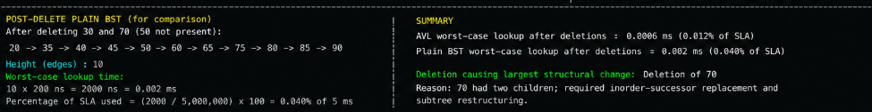
Key Features of the Code:-
Implements Binary Search Tree construction using ordered patient IDs.
• Implements AVL Tree insertion with automatic self-balancing.
• Supports LL, RR, LR, and RL rotation cases.
• Maintains node heights for balance-factor calculation.
• Preserves O(log n) search complexity through AVL balancing.
• Handles deletion operations while maintaining AVL properties.
• Computes tree height and lookup performance metrics.
• Compares balanced and unbalanced tree structures.
• Efficient traversal using recursive insertion and deletion.
• Time complexity:
• BST Search: O(n) worst case
• AVL Search: O(log n)
• AVL Insertion: O(log n)
• AVL Deletion: O(log n)
• Suitable for hospital indexing systems, database indexing, and real-time search applications.
Conclusion Line (for Report):
The implementation demonstrates that insertion order significantly affects the performance of a Binary Search Tree, often resulting in a skewed structure with increased search cost. In contrast, the AVL Tree maintains balance through rotations, ensuring efficient lookup operations and consistent logarithmic performance. Therefore, AVL Trees are highly suitable for real-time patient indexing systems where fast and predictable search performance is critical for meeting strict healthcare service-level requirements.

GitHub Link:

Student Signature | Faculty Signature

